Abstract—This electronic document is the template of Microsoft Word for the 1-page paper submissions to 原力覺醒創意構想競賽.
專題Title
作者First A. Author, Second B. Author, and Third C. Author

Introduction簡介
This template provides authors with most of the formatting specifications needed for preparing electronic versions of their papers. The overall paper (including references and figures) cannot exceed one page limit. Do not change the margins, column widths, font sizes or line spacing to squeeze more text into a limited number of pages. Use italics for emphasis; do not underline.

Method研究方法
Define abbreviations and acronyms the first time they are used in the text, even after they have been defined in the abstract. Do not use abbreviations in the title or heads unless they are unavoidable [7]. Use either SI (MKS) or CGS as primary units. (SI units are encouraged.)

- Table Type Styles
Table Head | Table Column Head
Table Head | Table column subhead | Subhead | Subhead
copy | More table copyª
a. Sample of a Table footnote. (Table footnote)

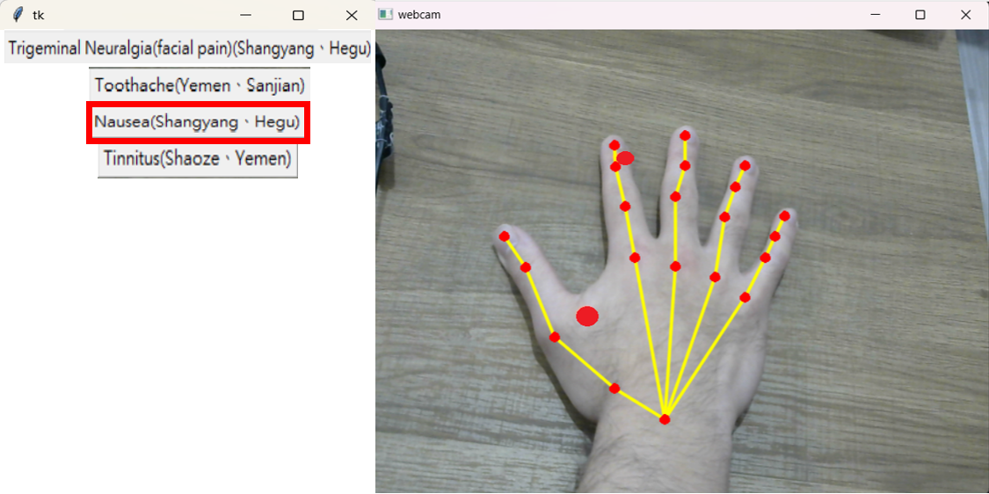
- Example of a figure caption. (figure caption)

Figure Labels: Use 8 point Times New Roman for Figure labels. Use words rather than symbols or abbreviations when writing Figure axis labels to avoid confusing the reader. If including units in the label, present them within parentheses. Do not label axes only with units. In the example, write “Magnetization (A/m)”, not just “A/m”. Do not label axes with a ratio of quantities and units. For example, write “Temperature (K)”, not “Temperature/K.”

Results成果
Please indicate conclusion and future work of this paper.
References
- G. O. Young, “Synthetic structure of industrial plastics (Book style with paper title and editor),” in Plastics, 2nd ed. vol. 3, J. Peters, Ed. New York: McGraw-Hill, 1964, pp. 15–64.
- W.-K. Chen, Linear Networks and Systems (Book style). Belmont, CA: Wadsworth, 1993, pp. 123–135.

 作者資訊F. A. Author is with the National Institute of Standards and Technology, Boulder, CO 80305 USA (corresponding author to provide phone: 303-555-5555; e-mail: author@boulder.nist.gov). S. B. Author, Jr., was with Rice University, Houston, TX 77005 USA. He is now with the Department of Physics, Colorado State University, Fort Collins, CO 80523 USA (e-mail: author@lamar.colostate.edu). T. C. Author is with the Electrical Engineering Department, University of Colorado, Boulder, CO 80309 USA, on leave from the National Research Institute for Metals, Tsukuba, Japan (e-mail: author@nrim.go.jp).

